# Clean Up with CTEs

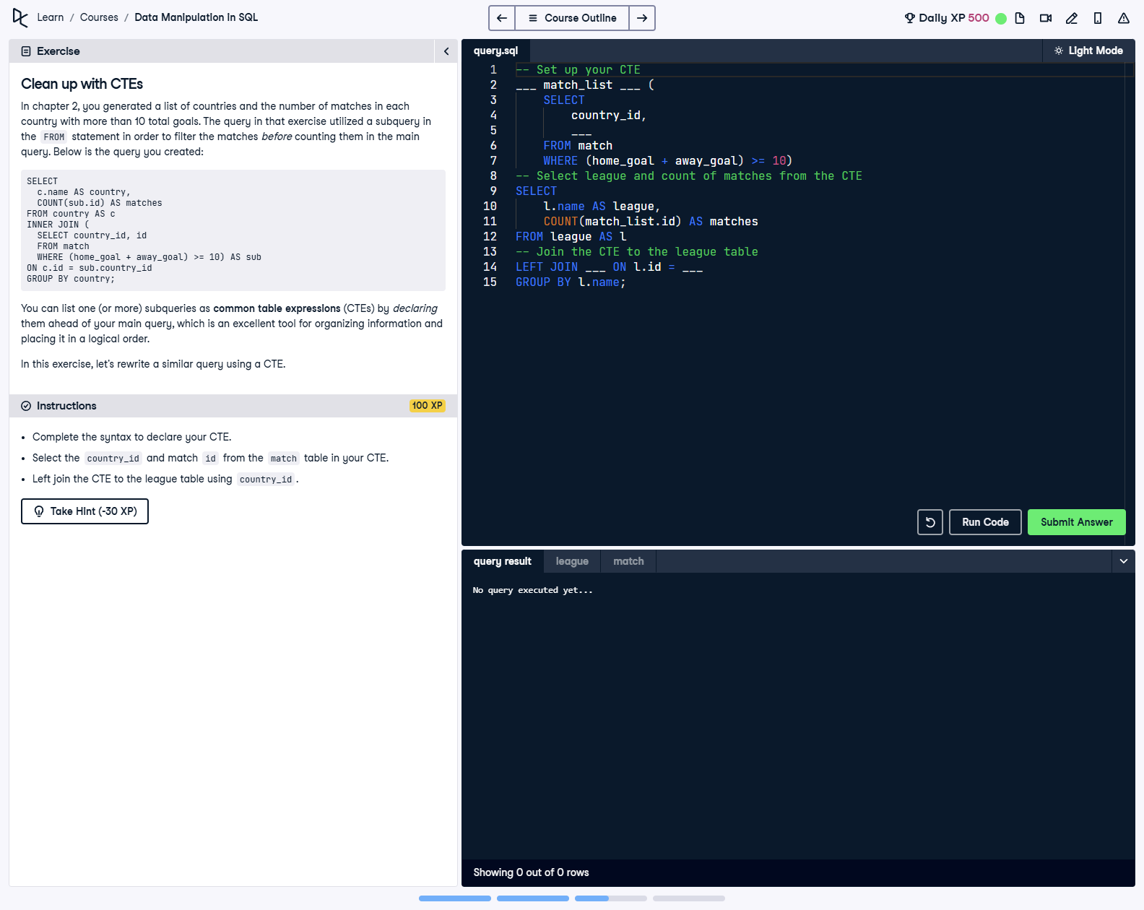

## Question

1. Complete the syntax to declare your CTE.  
  
2. Select the country_id and match id from the match table in your CTE.  
  
3. Left join the CTE to the league table using country_id.

## Corrected Solution

-- Set up your CTE  
WITH match_list AS (  
 SELECT  
 country_id,  
 id  
 FROM match  
 WHERE (home_goal + away_goal) >= 10  
)  
-- Select league and count of matches from the CTE  
SELECT  
 l.name AS league,  
 COUNT(match_list.id) AS matches  
FROM league AS l  
LEFT JOIN match_list  
ON l.id = match_list.country_id  
GROUP BY l.name;

## Explanation

This query calculates the number of high-scoring matches (10+ goals) for each league using a Common Table Expression (CTE). The CTE, defined with the WITH clause, isolates matches with the specified criteria, making the query more readable and modular. The main query joins the CTE to the league table and aggregates the results by league name using COUNT and GROUP BY.